**ANGULAR PROJECT**

**HomeEase - Home Service Booking Platform**

A Seamless Way to Connect with Service Providers

**PROJECT OVERVIEW**

* Web-based platform for home service bookings.
* Connects users with verified service providers.
* Users can browse, book services, submit inquiries, and provide feedback.

**PROJECT SETUP:**

**STEP 1: COMPONENTS CREATION**

• Create modular and reusable components for the application.

• Implement core components such as Menubar, Home,About Us, Service Providers,Inquiry, Contact, and Dashboard.

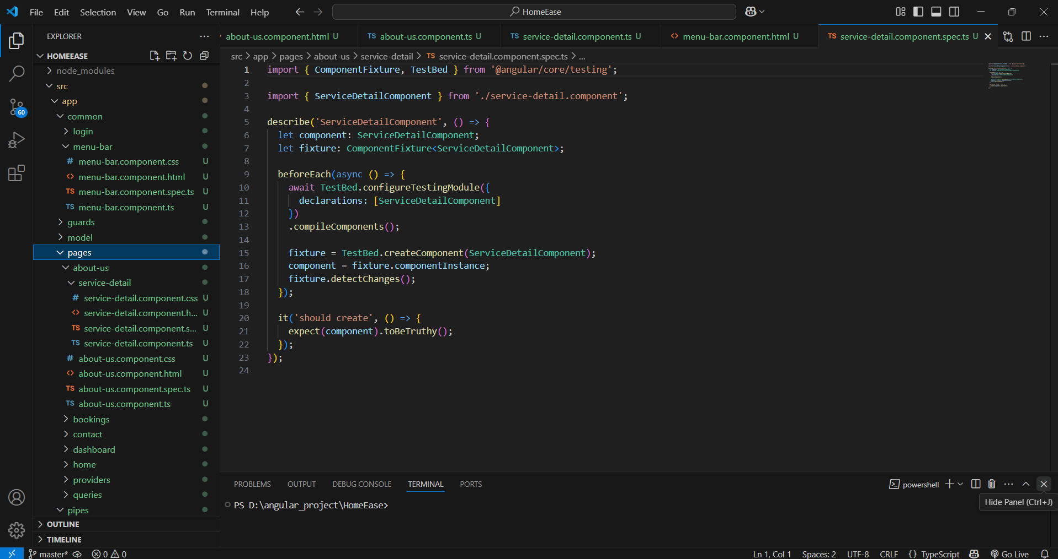

**STEP 2: PARENT-CHILD COMPONENTS**

• Implement parent-child communication using @Input and @Output decorators.

• Ensure seamless data flow between parent and child components for user interactions.

Aboutus(Parent)-Service-detail(Child)

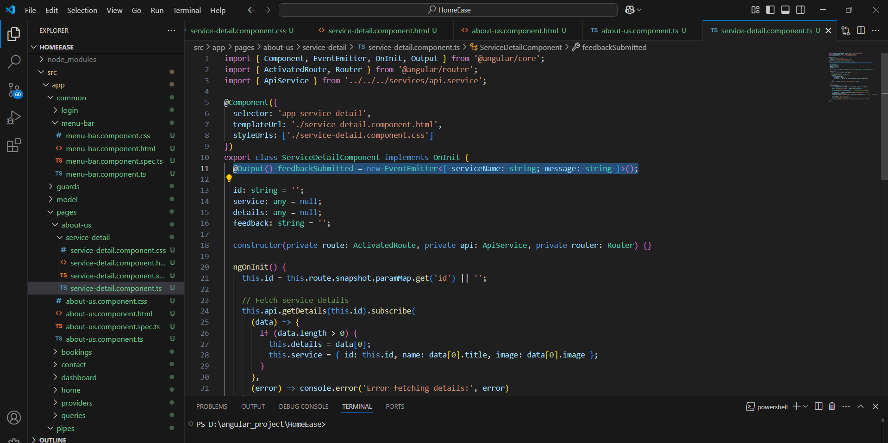

**STEP 3: LOCAL STORAGE**

• Store user preferences and session data using local storage.

• Implement a mechanism to persist user authentication state.

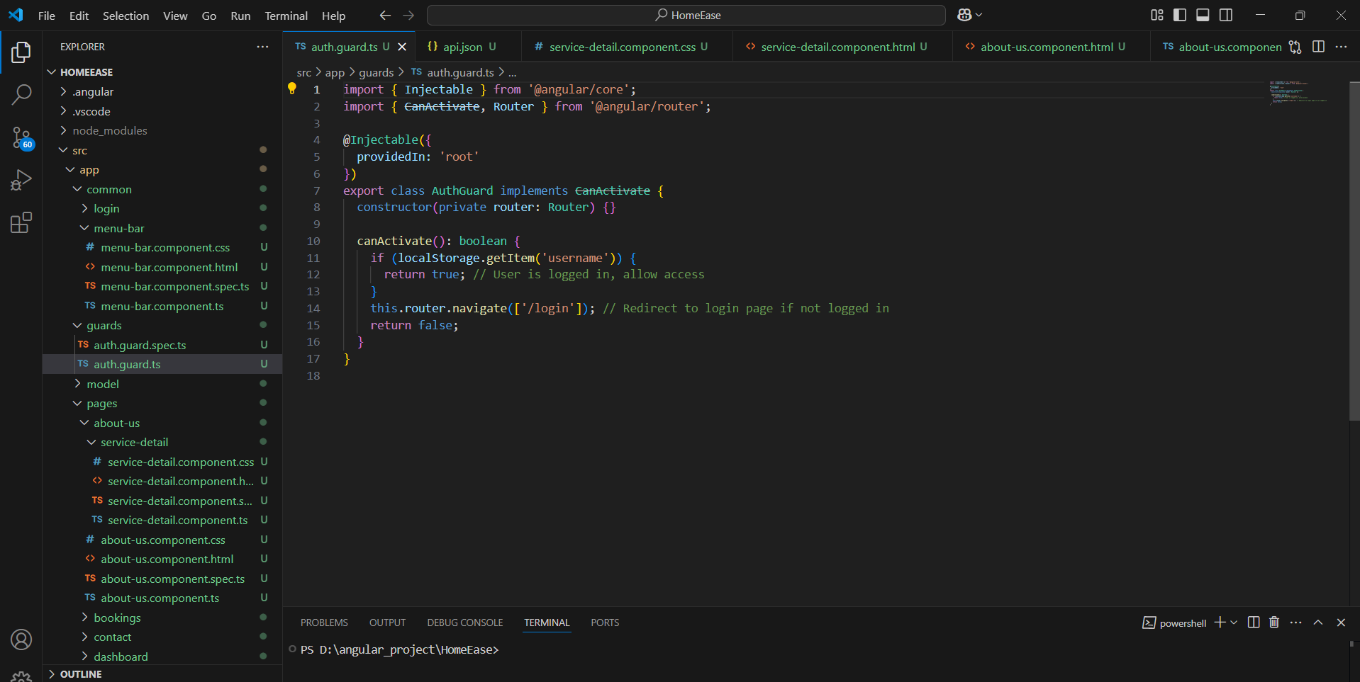

**STEP 4: ROUTING GUARD**

• Implement authentication guards to protect certain routes.

• Ensure that only authenticated users can access restricted pages.

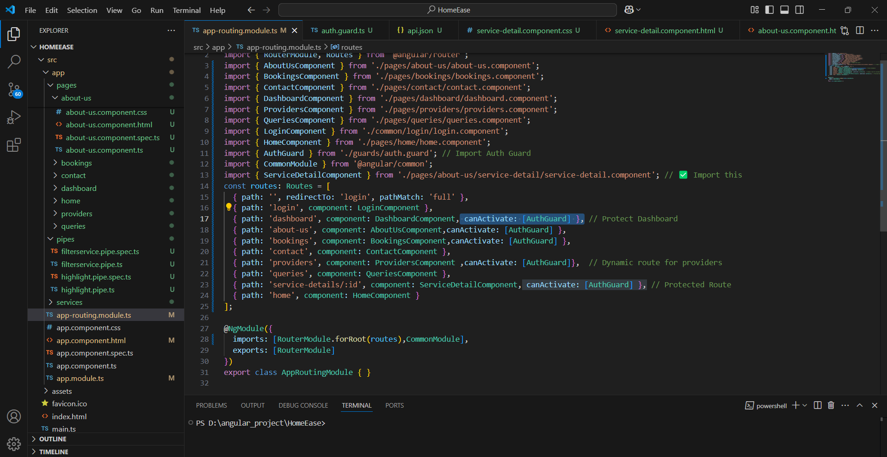 **STEP 5: API CALL**

• Integrate backend APIs for dynamic data retrieval and storage.

• Use HTTP Client Module to fetch data from the server.

**API.JSON**

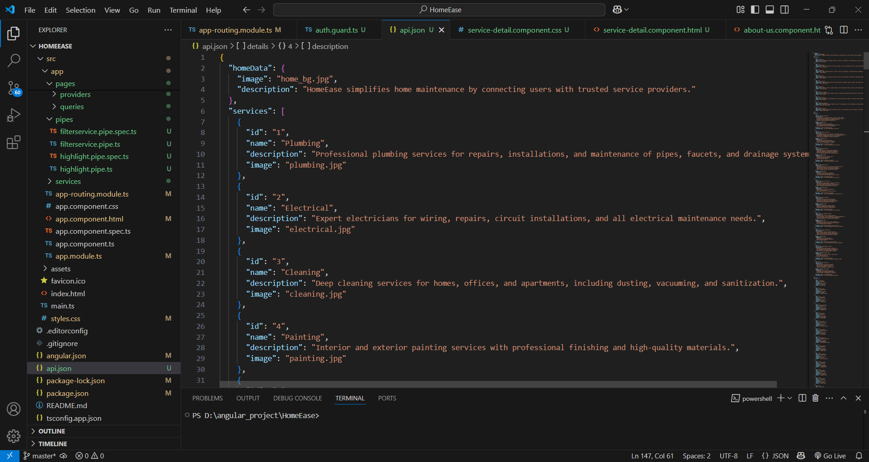

**STEP 6: INBUILT PIPES AND CUSTOM PIPES**

• Utilize Angular’s built-in pipes for data transformation (Currency, Date, UpperCase, etc.).

• Create custom pipes for specific data formatting needs.

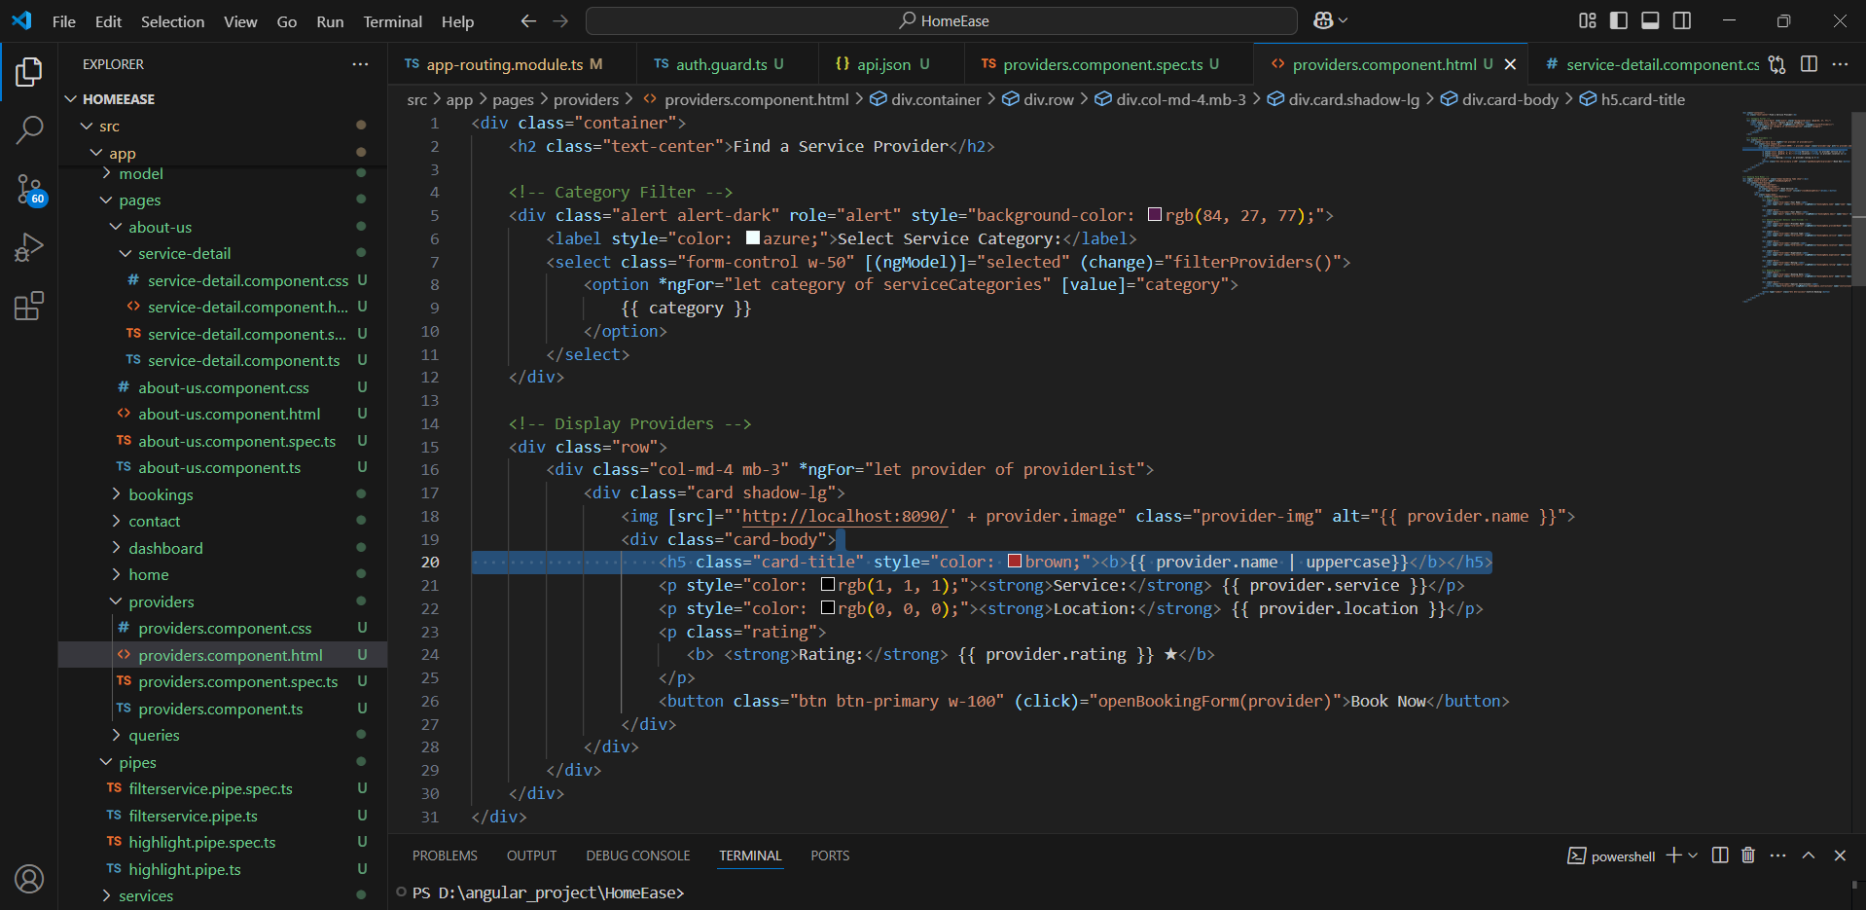

• Create custom pipes for specific data formatting needs.

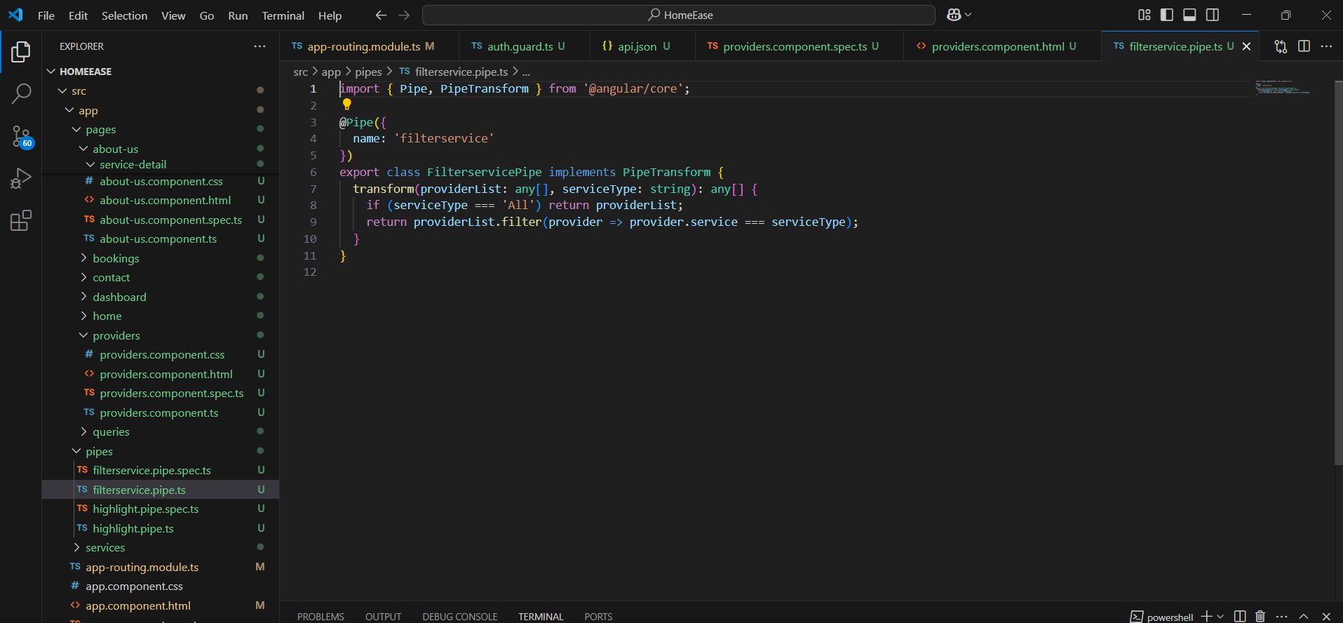

**OUTPUT**

**NAVIGATION FLOW**

1. **Login Page**
   * Users enter credentials to access the platform securely.

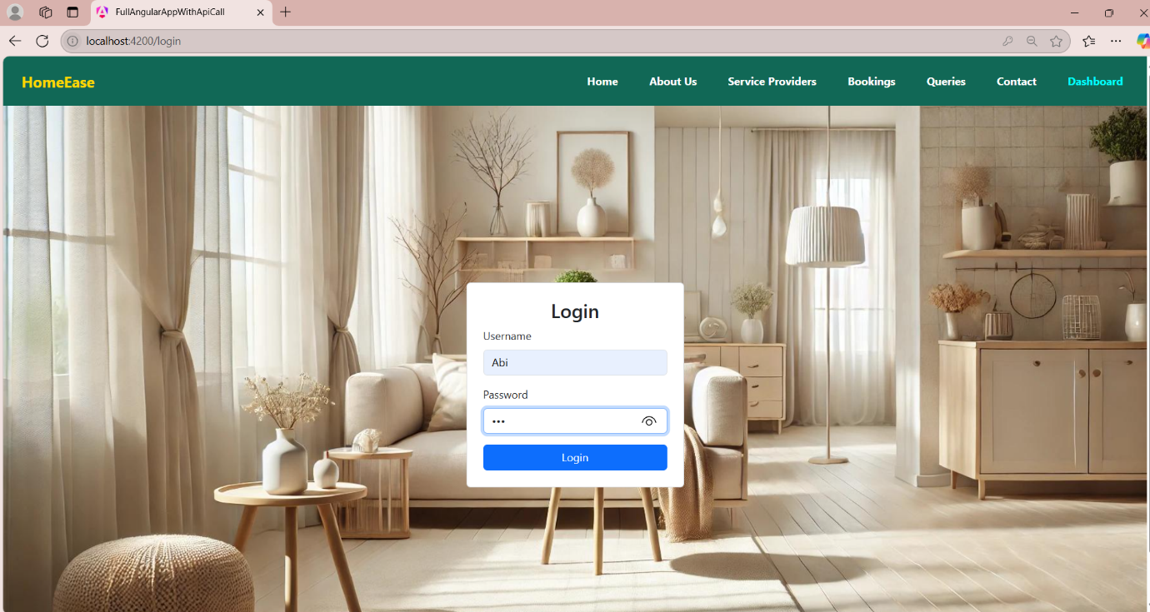

1. **Home Page**
   * Displays mission, vision, and an overview of HomeEase.

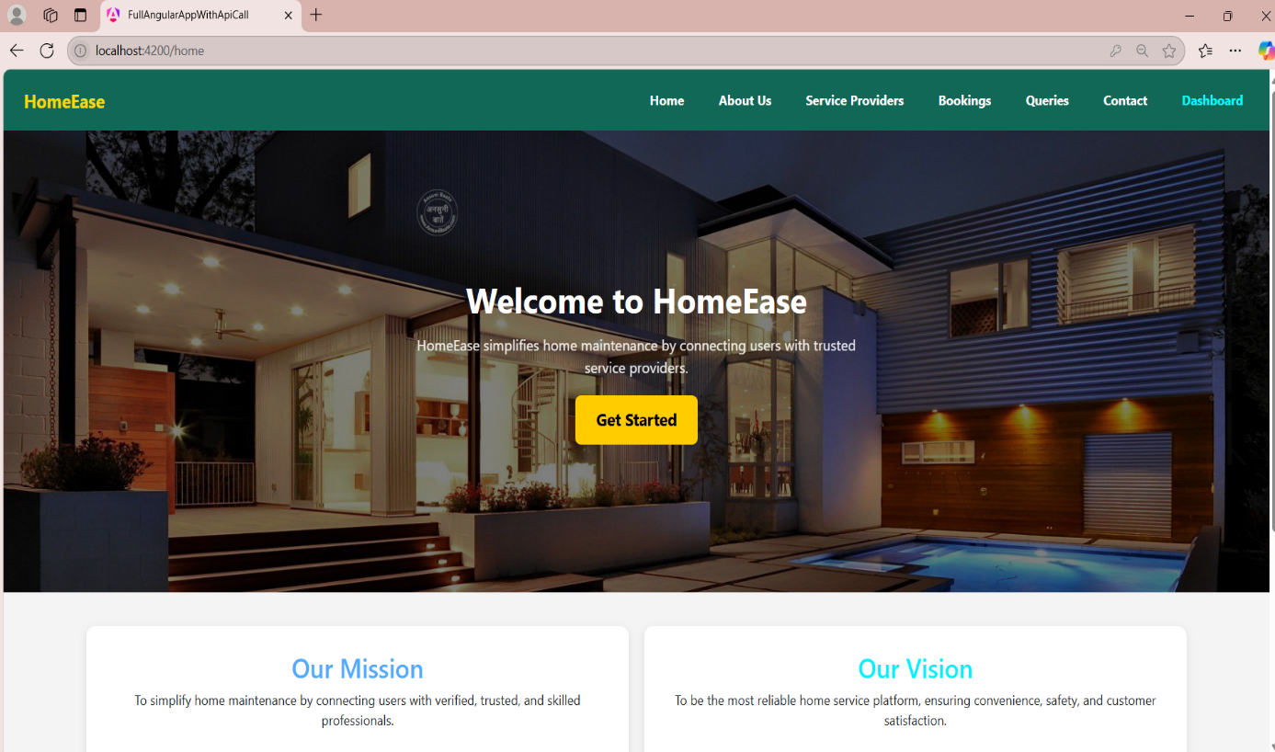

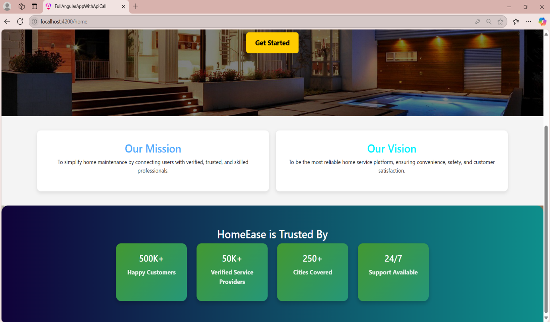

1. **About Us Page**
   * **Displays service categories with brief descriptions.**

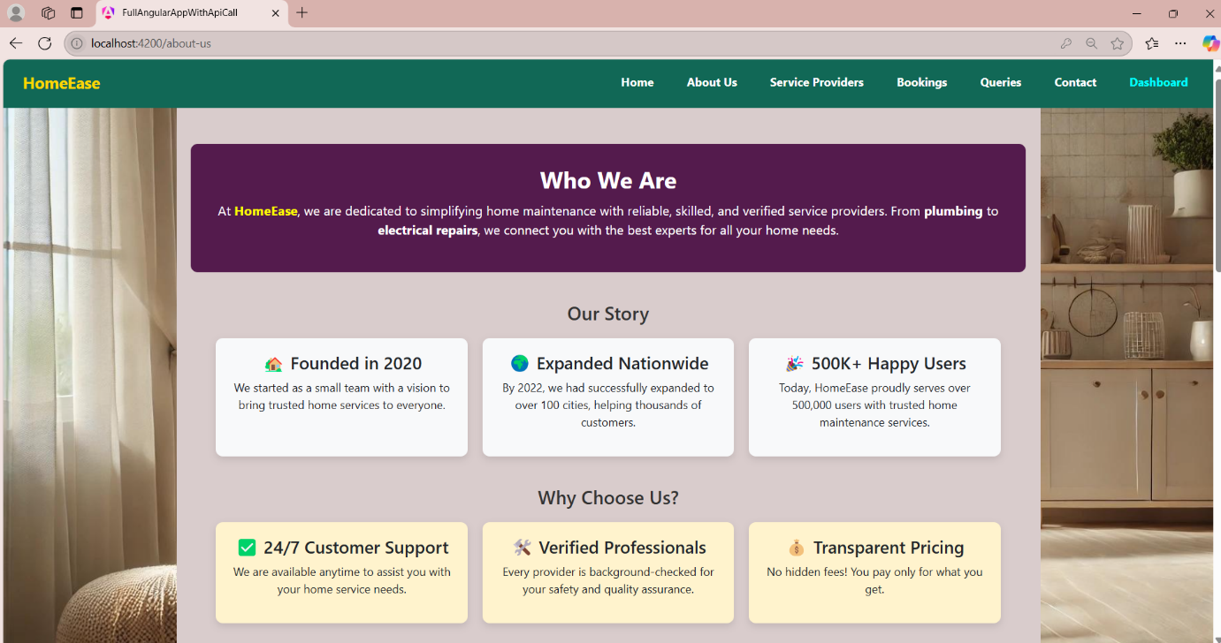

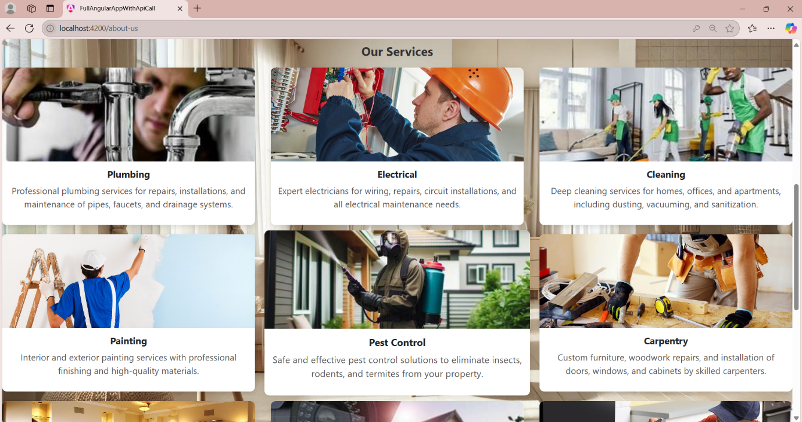

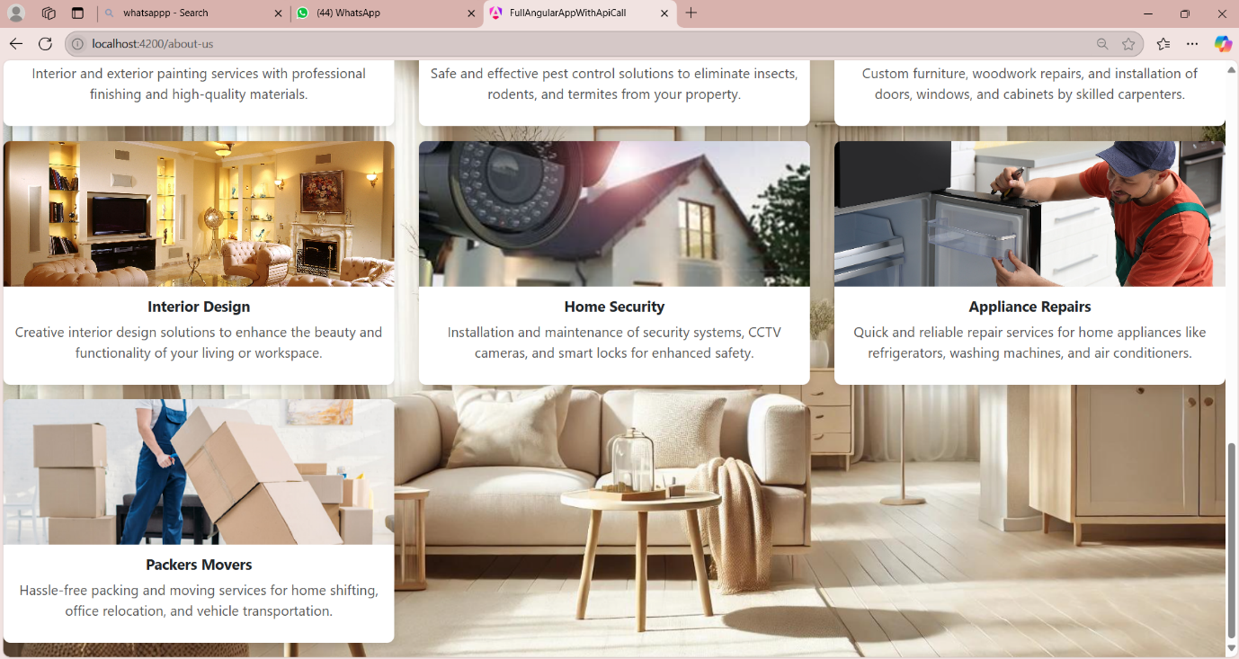

* **Each service card contains a detailed description and user feedback.**

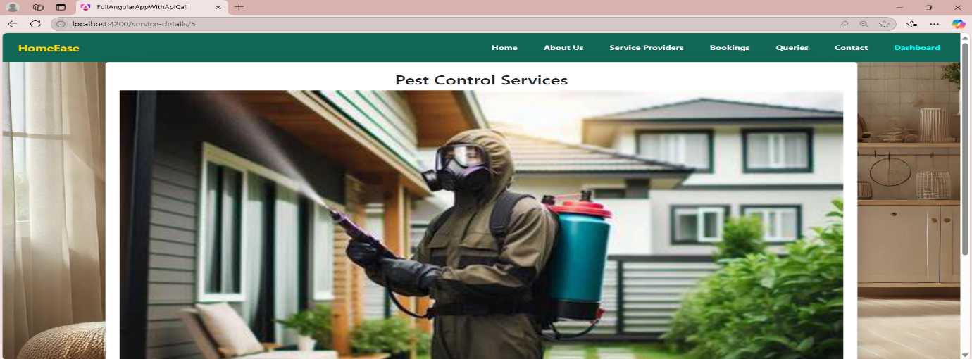

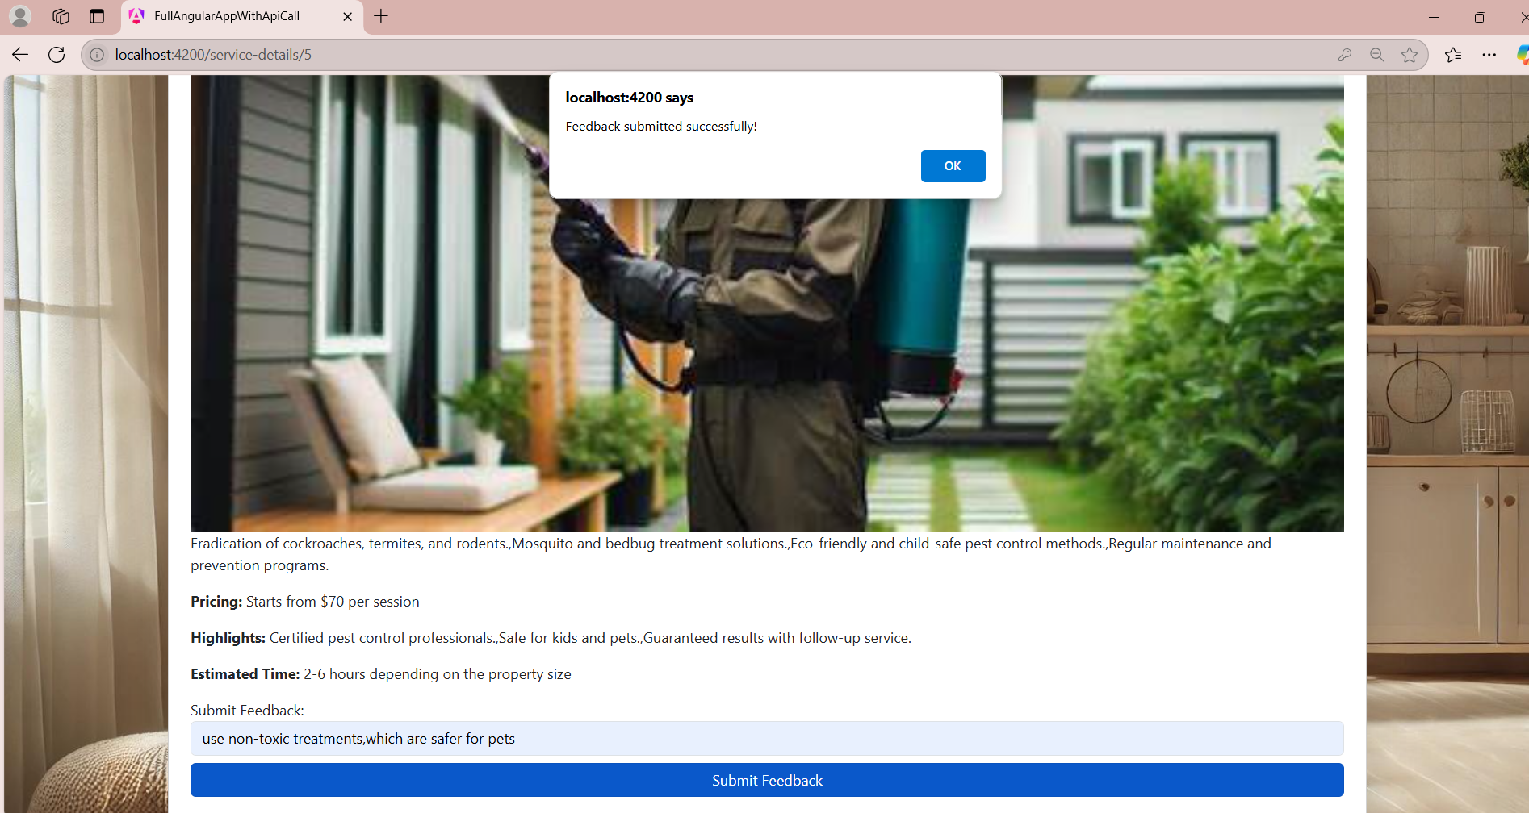

* + **Submitted feedback is sent to the About Us page for display.**

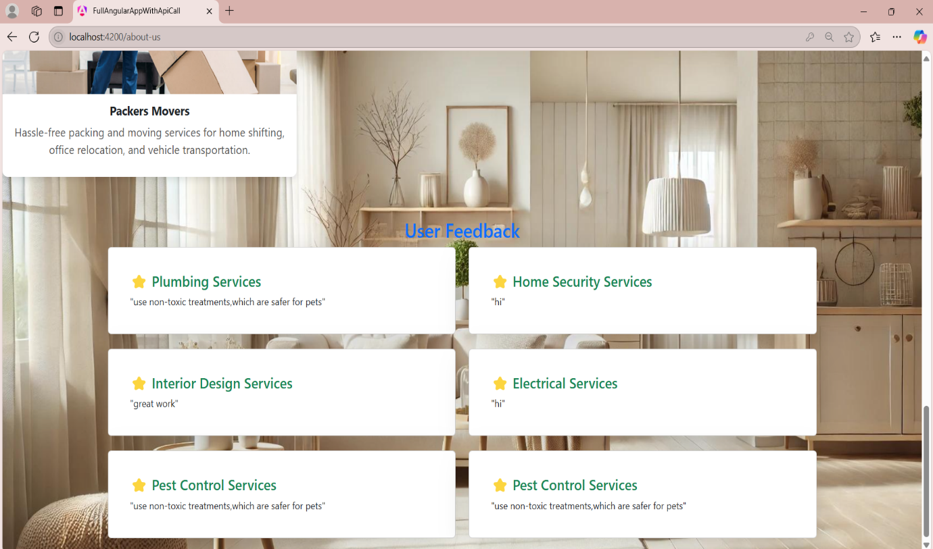

1. **Service Provider Page**
   * Lists providers with details like name, rating, and location.Users can filter service providers based on service type.
   * Users can click on "Book Now" to schedule services.
   * Booked services are displayed on the Bookings Page.

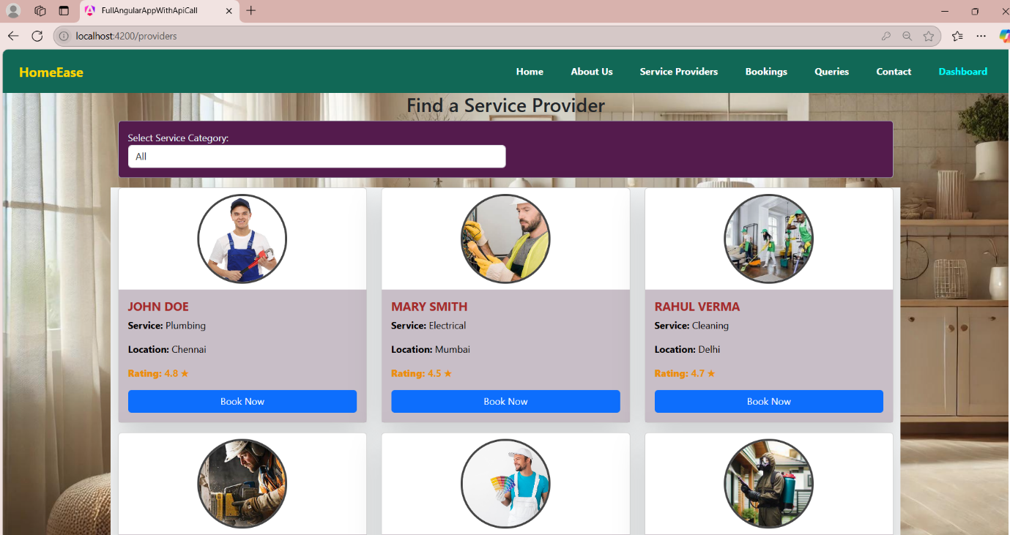

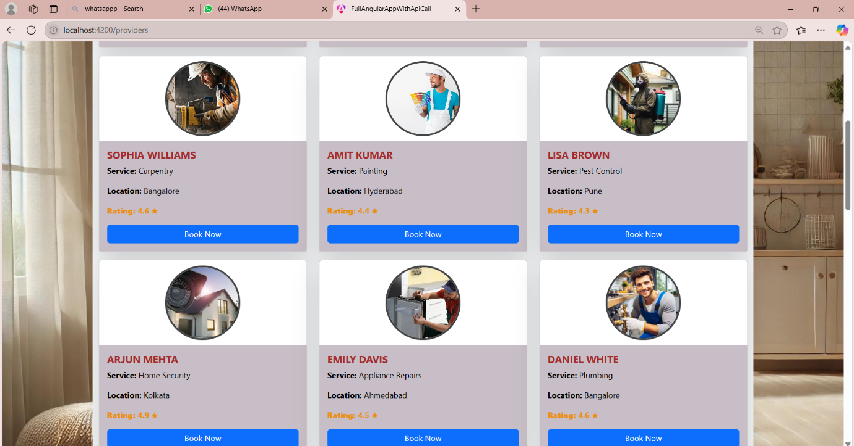

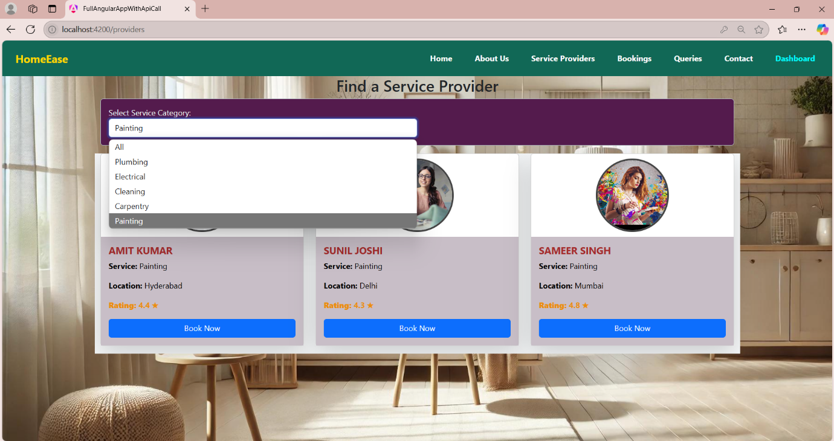

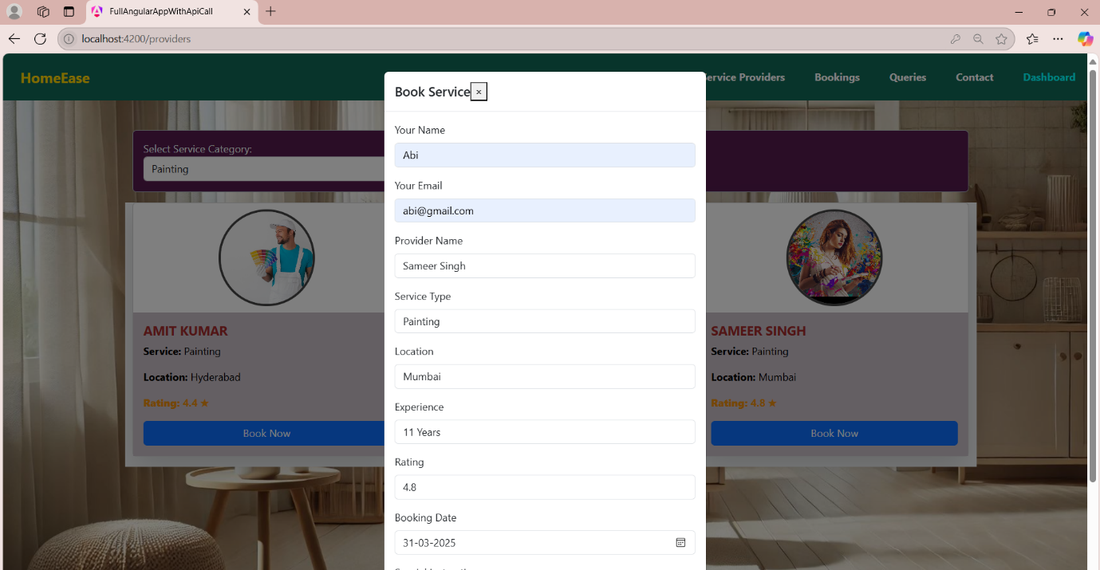

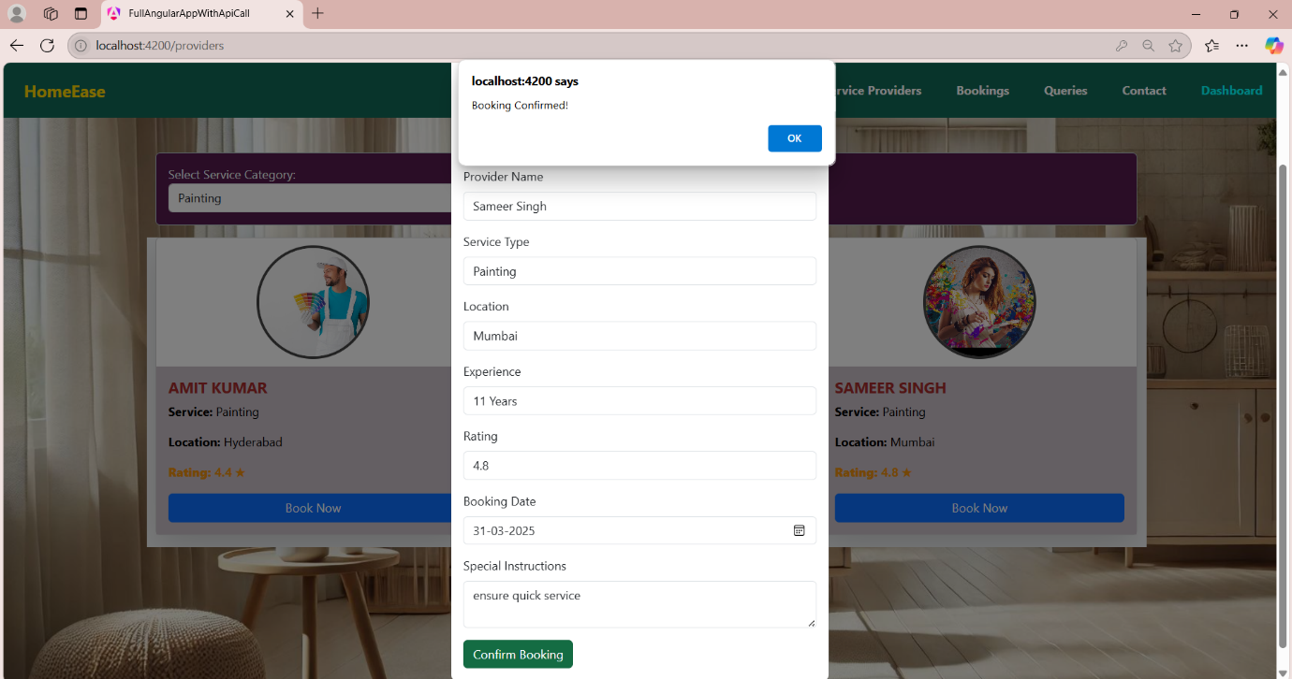

1. **Booking Page**
   * Lists user reservations with booking status and details.
   * Allows users to manage and track their bookings.

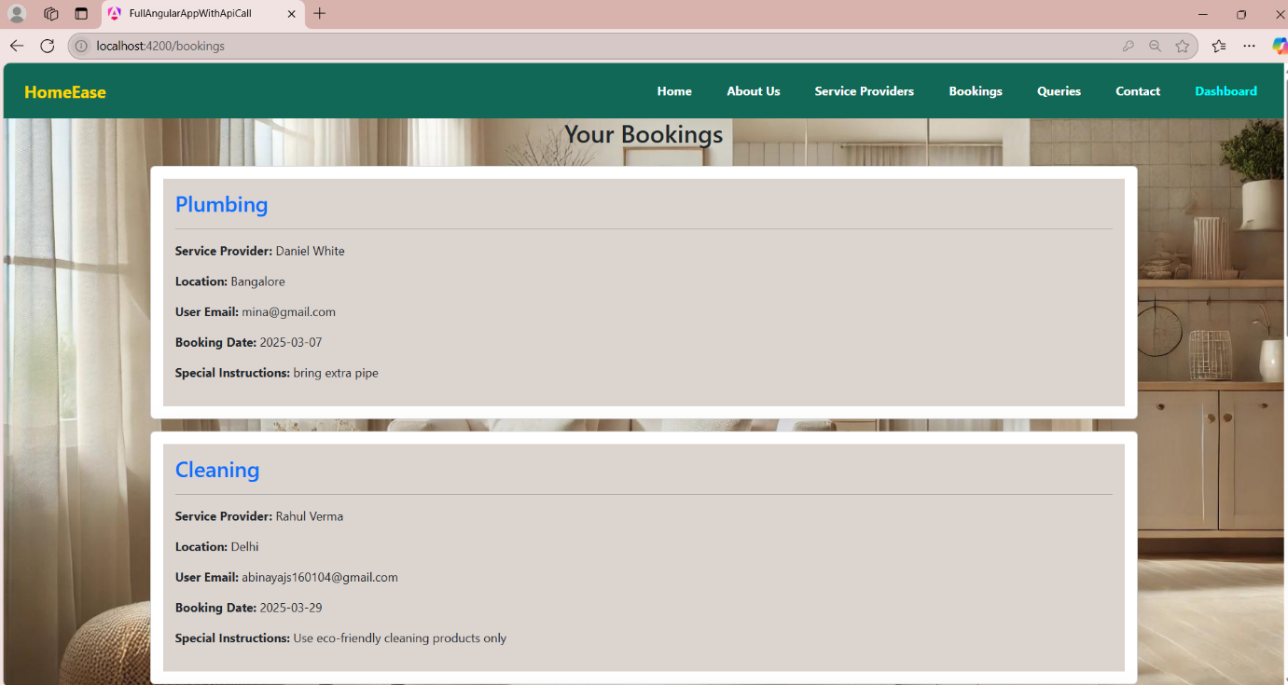

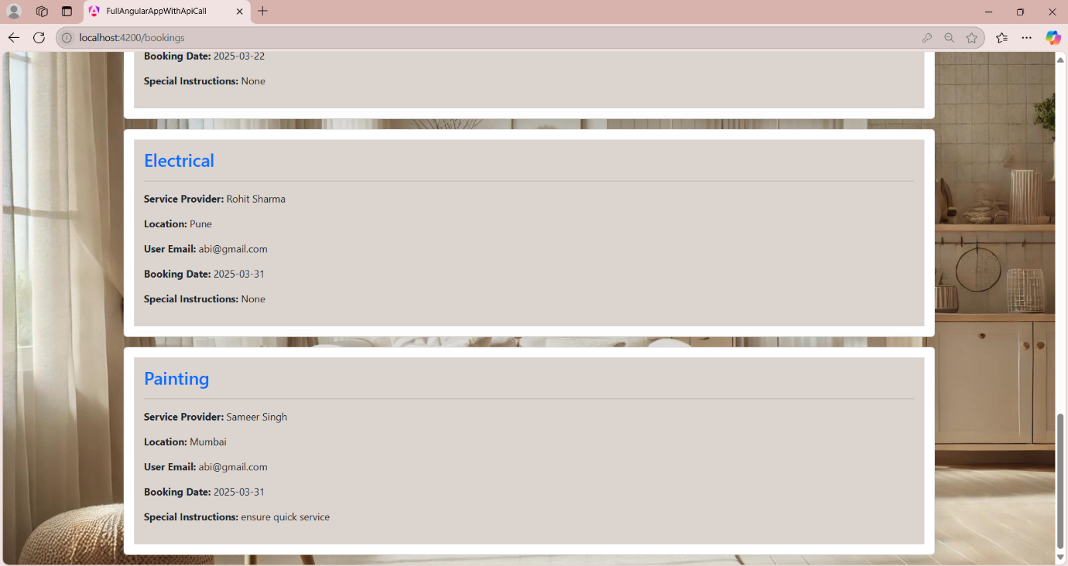

1. **Inquiry Page**
   * Users can submit queries for assistance.

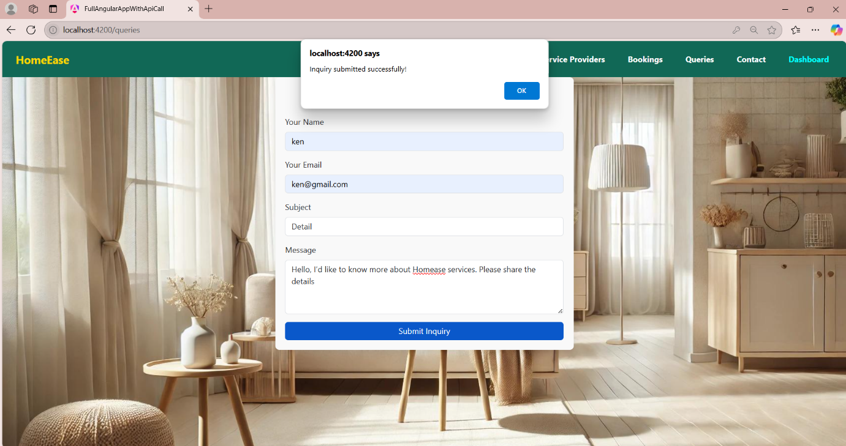

1. **Contact Page**
   * Displays company location, contact details, address, working hours, and an interactive map for easy navigation.

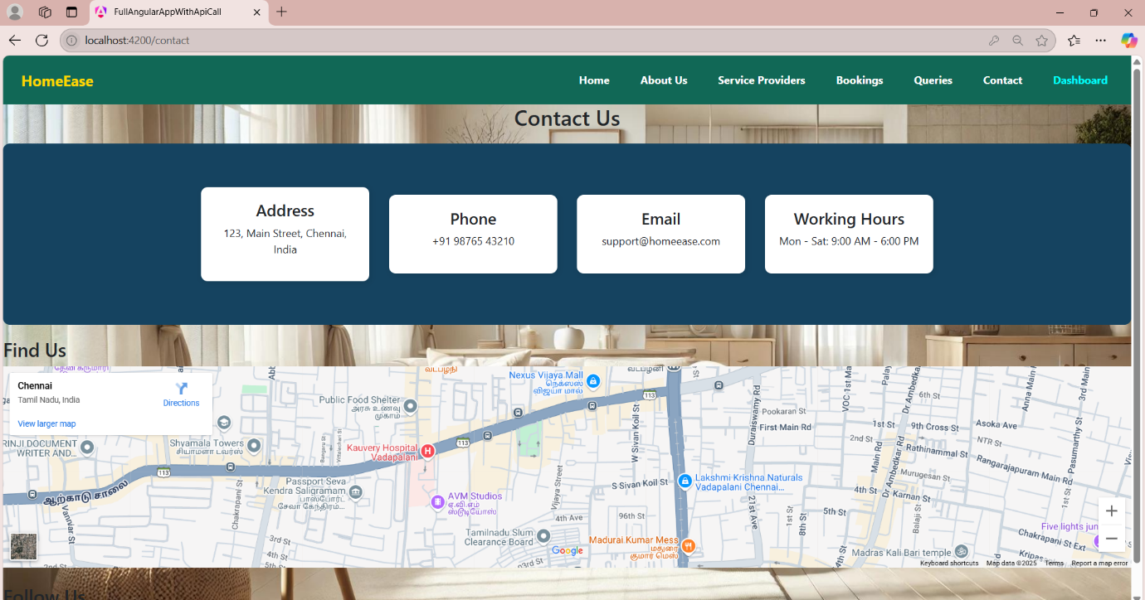

1. **Dashboard Page**
   * Displays user profile with navigation and logout option.

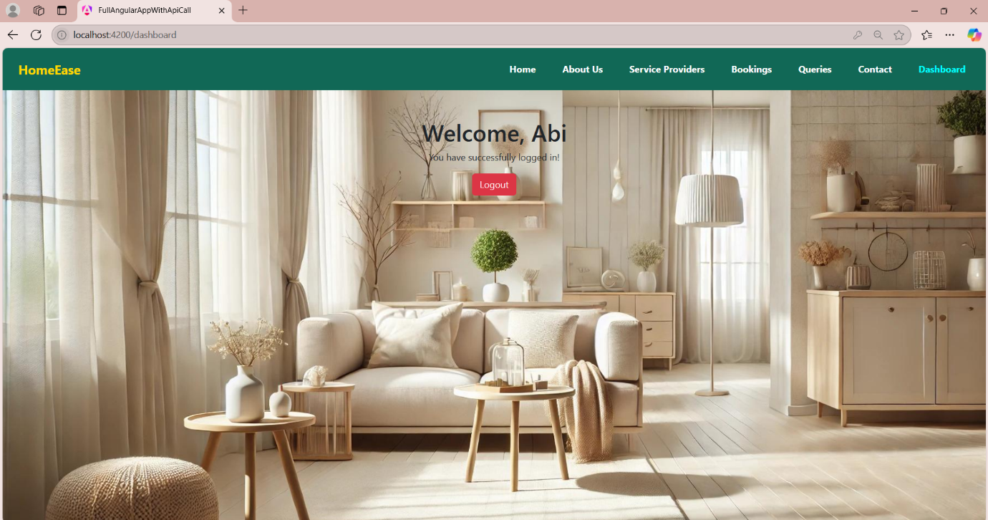

**TECHNOLOGY STACK**

* **Frontend:** Angular (TypeScript)
* **Styling:** Bootstrap, CSS
* **API Handling:** Angular Services & RxJS
* **Routing:** Angular Router (configured in app-routing.module.ts)
* **State Management:** Observables & Services
* **Component Structure:** Modular & reusable for better development workflow
* **Data Handling:**
  + Local Storage: Stores authentication details & user feedback
  + Angular Services: Manages dynamic data flow
* **Authentication & Security:**
  + Login redirects to Home Page after authentication
  + AuthGuard restricts access to prevent unauthorized navigation

**CONCLUSION**

✅ HomeEase simplifies home service bookings. ✅ Secure authentication ensures data protection. ✅ Modern web technologies provide a smooth user experience. ✅ User-friendly navigation enables hassle-free booking.